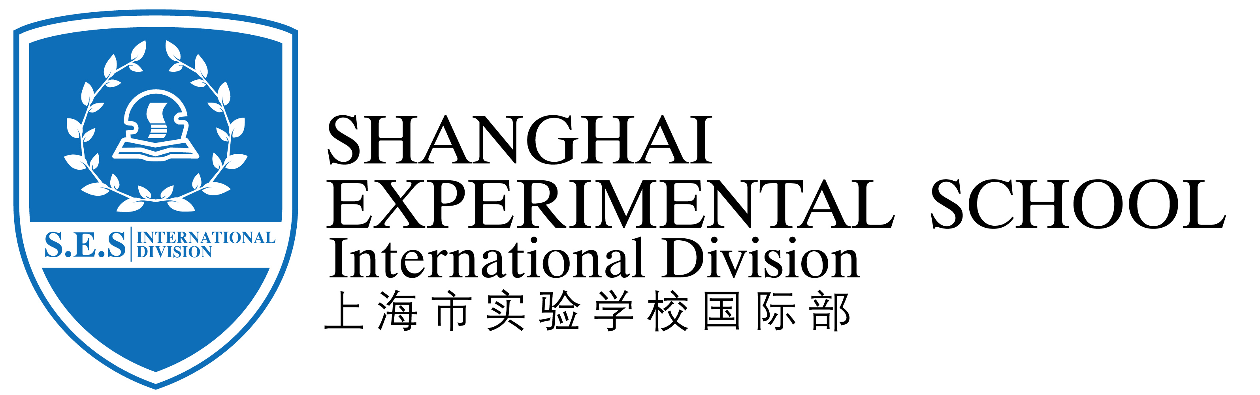
Kids Menu
( Nov 12— Nov 16,2018 )
Date | Day | Menu
Nov. 12 | Monday | 红烧肉圆、美味凤柳、三鲜鱼面筋、榨菜肉丝蛋花汤  Braised pork, chicken, fish, gluten and mustard soup
Nov. 13 | Tuesday | 虾仁炒蛋、扬州炒饭、西芹牛肉丝、果酱面包、油豆腐粉丝虾皮汤  Shrimp omelette, Yangzhou fried rice, celery beef fillet, jam bread, oil bean curd, vermicelli and shrimp skin soup.
Nov. 14 | Wednesday | 急汁牛肉饼、港式蒸饺、花菜木耳肉片、香菇青菜、扁尖冬瓜汤  Beef pie, Hong Kong style steamed dumplings, cauliflower, fungus slices, letinous edodes vegetables, and winter melon soup.
Nov. 15 | Thursday | 烤鸡翅、鲜茄鸡丝意面、炸薯条、奶油西兰花、鸡丝粟米羹  Roasted chicken wings, fresh tomato, chicken noodle, French fries, French fries, cream broccoli, chicken and corn soup.
Nov. 16 | Friday | 蚝油牛肉、泰式烤鱼、蒸大蛋饺、炒杭白菜、番茄蛋花汤  Oyster sauce beef, Thai roast fish, steamed big egg dumplings, fried cabbage, tomato and egg soup

